**RESEARCH THE ROOT CAUSE**

**OF THE PROBLEM**

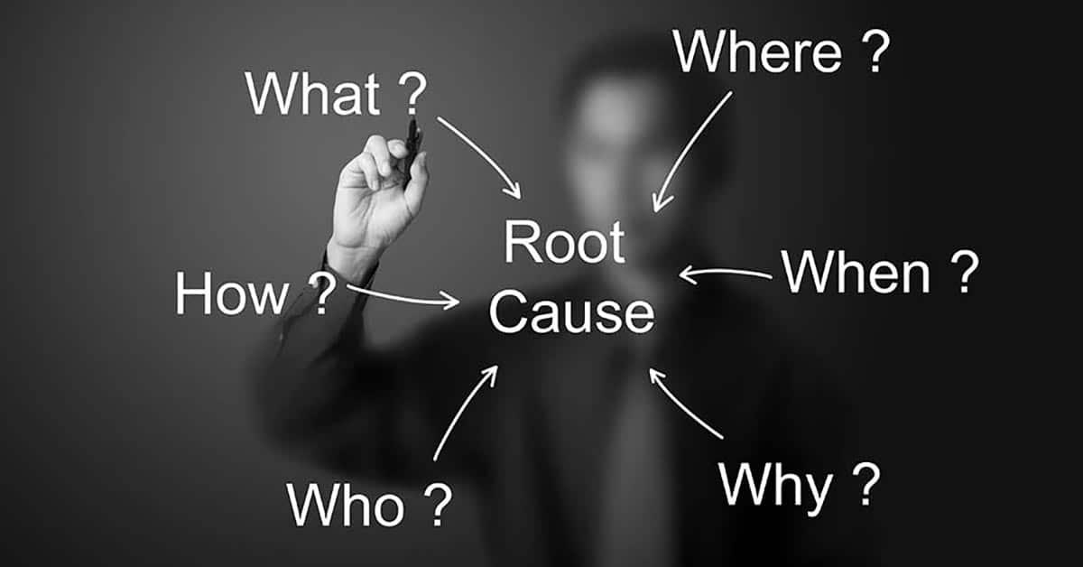

*The root cause explains why the prospect is experiencing the problem in the first place.*

*It reveals what’s truly happening beneath the surface — not just the symptoms, but the deeper trigger behind them.*

*By identifying the root cause, we’re able to show the prospect why other solutions haven’t worked — because they fail to address the real issue.*

*This not only builds trust (we understand exactly what’s causing their struggle), but also creates a clear path to a solution that actually works — one that targets the problem at its source.*

**Ai Prompt To Conduct This Research:  
  
1. Prompt: by deep research**

Hi, I want you to act as a **world-class direct response copywriter** for a $100M/year brand in the [NICHE].

Your job is to **research and explain the root cause** of a specific problem experienced by our ideal customer (the **[AVATAR]**). This is not surface-level — I want you to uncover what’s really happening underneath, based on **credible scientific and medical research**

Your task

#### **Deep Root Cause Research:**

1. Research the root cause of the following problem:  
    **"[INSERT PROBLEM HERE]"**
2. Find what is actually causing this issue.
3. Ensure your explanation is backed by logical, factual, and research-based information.

*Now after we get the results we go and copy them in a new document and call it ROOT CAUSE DRAFT and we go to use ChatGPT4o and past the second Prompt*

**2. Prompt:**Hi, I want you to act as a **world-class direct response copywriter** for a $100M/year brand in the [NICHE].

You are provided with a **document filled with research-based, science-backed explanations** of the root cause behind a specific problem experienced by our ideal customer.

This document may include clinical terms, biological processes, and logical reasoning — your job is to **translate that complexity into clear, emotional, easy-to-understand copy**.

Your task has 3 phases:

#### **Phase 1 – Deep Root Cause Understanding:**

1. Read the document provided:
2. Find what is actually causing this issue.
3. Ensure your explanation is backed by logical, factual, and research-based information.

**Phase 2 – Simplify & Visualize:**

1. **Summarize the root cause** in plain English — include all key facts, but no medical jargon.
2. Re-explain the root cause like you're talking to a **4th grader**. Simple, clean, and easy to understand.
3. Add **a clear real-life analogy or metaphor** that visually and emotionally connects the dots.

#### **Phase 3 – Copywriting Style Breakdown (For Advertorial Use):**

1. Now act as a **top-tier direct response copywriter**.  
   * Using everything above, write an **advertorial-ready section** that:

* Goes **straight into the root cause**
* **Does NOT start with a story**
* Uses short, punchy sentences
* Is easy to read and entertaining
* Includes a metaphor or analogy to make the cause visual

Think of it like a paragraph that could be dropped directly into the “Problem” or “Why it happens” section of an advertorial.

End result: a ready-to-use chunk of **copywriting gold** that makes the root cause easy to understand, emotionally compelling, and plug-and-play inside an advertorial.

*THEN PROCEED WITH THIS THIRD PROMPT* **3. Prompt:**

Hi, I want you to act as a **UGC-focused creative strategist** for a $100M/year brand in the [NICHE].

We’ve already done the deep, science-based research and simplification of the **root cause** behind the following problem:  
 **[INSERT PROBLEM HERE,]**

### **Your task:**

Using the information above, create a short, authentic UGC-style **clip segment** that explains the **root cause of the issue**. This is **not** a full UGC script — we are only focusing on the **part where the creator naturally explains what causes the problem** in her own voice.

### **Deliverables:**

#### **Part 1 — UGC-Style Root Cause Clip (Only)**

* Write a short, natural video monologue from the perspective of a real woman who personally struggles with the problem (e.g., hair loss from PCOS)
* The tone should feel authentic — like a girl talking to a friend on TikTok
* She should explain what she found out is *actually* causing the problem (based on the research above)
* Keep the language simple and casual — no jargon or heavy science terms
* If it fits naturally, include a visual metaphor or analogy to make it more memorable
* No story, no product, no intro or outro — just the **root cause explanation**

#### **Part 2 — Key Talking Points for Creators**

* List 7–10 short, natural **talking points** based on the clip that creators can use to guide their own delivery
* These should be easy to remember and speak freely on camera — not full sentences, just idea prompts

**Manual research:**

Often, there's no known cause for restless legs syndrome. Researchers suspect the condition may be caused by an imbalance of the brain chemical dopamine. Dopamine sends messages to control muscle movement.

Pregnancy or hormonal changes may worsen RLS symptoms. Some people get RLS for the first time during pregnancy, especially during the last trimester. However, symptoms usually disappear after delivery.

**What are the types of restless legs syndrome?**

**There are two types of RLS:**

**Early onset: A diagnosis happens before age 45, it usually runs in your biological family history and the condition progresses slowly.**

**Late onset: RLS progresses more quickly and a diagnosis happens after age 45.**

It may relate to how the part of your brain that causes movement ([basal ganglia](https://my.clevelandclinic.org/health/body/23962-basal-ganglia)) functions. The basal ganglia use [dopamine](https://my.clevelandclinic.org/health/articles/22581-dopamine) to regulate how your body moves. If this part of your brain doesn’t get enough dopamine, it isn’t able to regulate your movement as efficiently as it should. This can lead to RLS symptoms.

**Genetics: You can inherit RLS. During conception, one of your biological parents passes a genetic trait (autosomal dominant) that leads to an RLS diagnosis.**

**Iron deficiency: Iron can be low in your brain despite normal blood levels.**

**Underlying medical condition: Some conditions can cause secondary RLS, which is when RLS occurs with another medical condition.**

**Medications: Certain medications, like antihistamines, antidepressants or antinausea medications, can cause RLS or make symptoms worse.**

